1. whoami → Display the usename

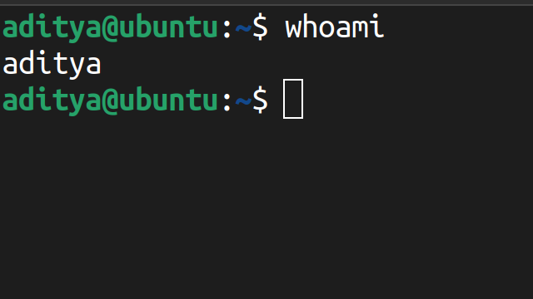

2. hostname → Displays the hostname

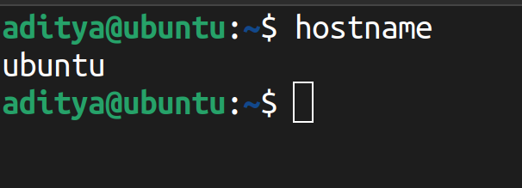

3. ls → Displays the list of directories

4. ls -la → Displays the list of directories including hidden files and other details

5. pwd → Displays the current working directory

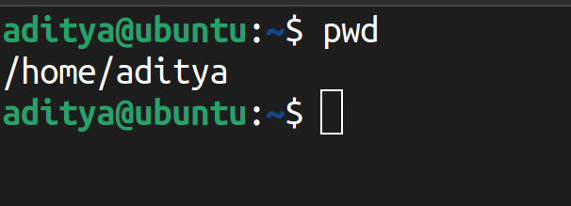

6. cd <dir name> → To access the directory

7. cd .. → To go back to the previous directory

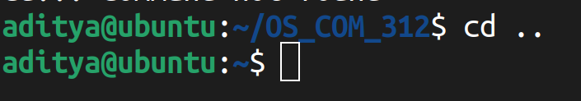

8 . touch <filename> → To create a file

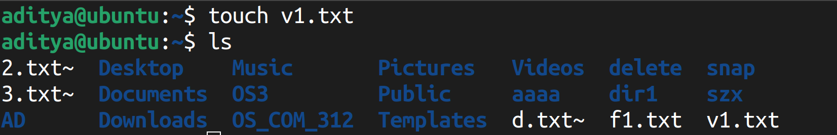

9. vi/nano <filename> → Creates a file and open in write mode

10. cat <filename> → Displays the content in the file

11. mkdir <dirname> → Creates a directory

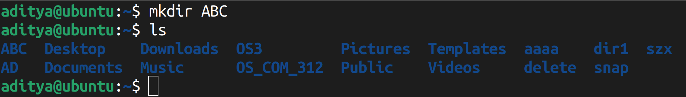

12. mkdir -v <dirname> → Creates a directory and displays the status

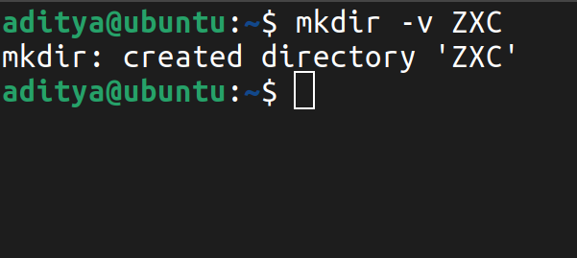

13 . mkdir -p <dirname/dirname2> → Creates a directory within a directory

14. rm <filename> → To remove/delete a file

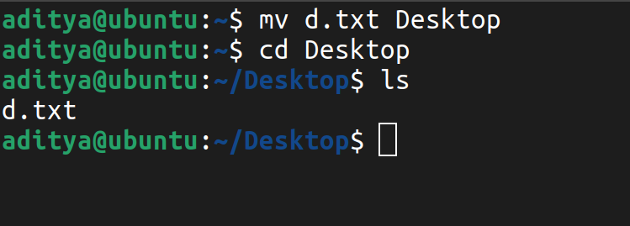

15. rmdir -r → To remove/delete a directory

16. mv <filename> <newname> → To rename a file

17. mv <filename> <path> → To move a file from a directory to a specified directory



18. cp<source><destination> - To copy the content of file to a new/existing file

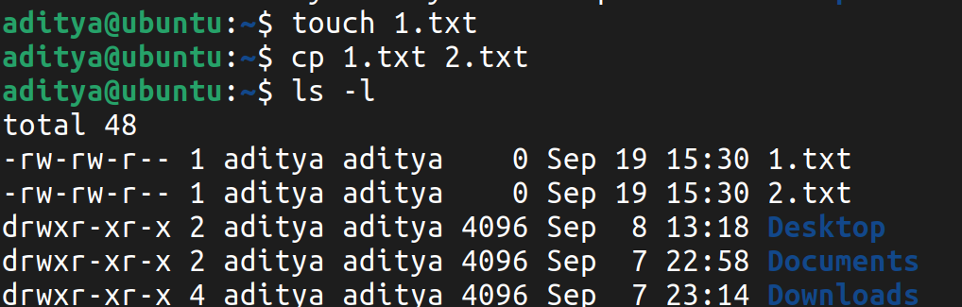

20. cat–n – Shows the number with each line in a file

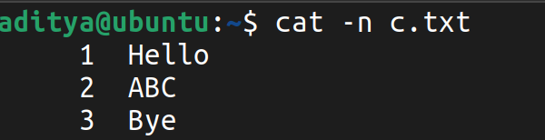

21. tac – Shows the content of a file in reverse order

22. cat <file1> >> file2 - displays the content of both files in file 2

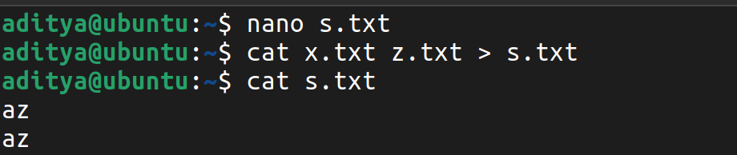

23. rm <filename> - used to delete a file from system

